**Lab Exercises (Use the following tables):**

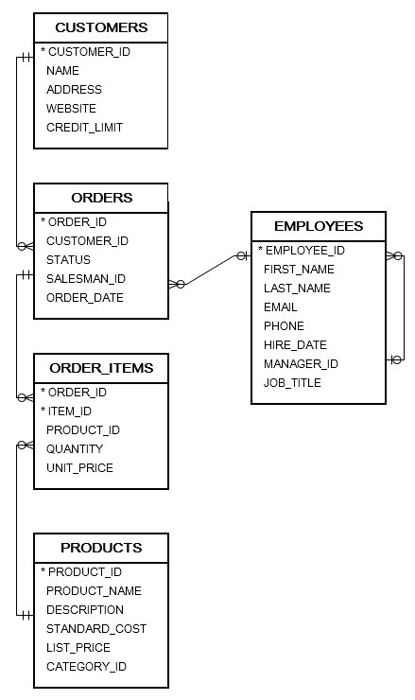

1. Write a query to display the customer’s name, customer address, order ID, Status, order date for all orders.
2. Write a query to display the product name, order id, order date, status, quantity, unit price for the order items having the product name started with ‘Intel’.
3. Write a query that will display all the orders that have the same salesman and having different order id, display them in pairs (order id1 and order id2 are served by first name).
4. Write a query that will display the order id, product name, unit price for all orders that has the unit price less than the unit price of order id 68.
5. Write a query to display the order id, product name. all product names must be shown including the products that didn’t requested in any order